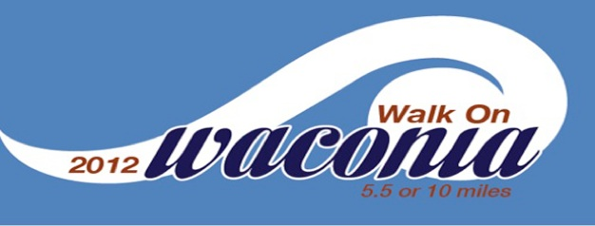
2011 Results:
6 Mile Run- Male
1st Place: Travis McCathie (41:49)
2nd Place: Tom Barrett (54:03)
3rd Place: John Biebighauser (101:54)

6 Mile Run- Female
1st Place: Becky McCathie (52:35)
2nd Place: Larissa Becker (53:25)
3rd Place: Kacie Harms (54:31)

10 Mile Run- Male
1st Place: Eric Kronback (1:04:18)
2nd Place: Philip Litfin (1:09:32)
3rd Place: Dave Just (1:11:56)

10 Mile Run- Female
1st Place: Celine Kronback (1:24:35)
2nd Place: Gina Sazama (1:24:41)
3rd Place: Kris Kuln (1:29:27)

10 Mile Relay
1st Place: John Backstrom and Sonja Monsen (1:24:31)
2nd Place: Amanda Melquist and Amy Ban Eps (1:56:13)

